CS1412, Spring 2021 Problem Solving & Program Design in C

Name: Bibek Dhungana

Lab 5 - In Lab Assignment

Due end of the lab session

Acknowledge your collaborators or source of solutions, if any. **Submission by the end of the LAB is required.** Please type your answers, handwritten submission will not be accepted. Do all of the following. A subset of your solutions will be graded.

1. For each of the following functions, explain its purpose, in one sentence
   1. isupper: This function defined in ctype.h check if the character is upper case on not. The character is upper case if it returns nonzero value.
   2. strlen

This function is defined in string.h which takes string as the argument and return its length.

* 1. strcat

This function from string.h takes two string as argument and concatenates those strings.

strcat(destination, source). Both destination and source are of string type.

1. Write a program in C to remove characters in a string except for alphabets.

Example:

Input: a2bc_d3ef.gh Output: abcdefgh

**Program:**

//including all the required libraries

#include <stdio.h>

#define SIZE 100

int main() {

   char myString[SIZE];

   //asking input from the user

   printf("Enter string you want to modify ");

   fgets(myString, sizeof(myString), stdin);

    //running loop to access each character

   for (int i = 0, j; myString[i] != '\0'; ++i) {

      //checking if chracter is except alphabet

      while (!(myString[i] >= 'a' && myString[i] <= 'z') && !(myString[i] >= 'A' && myString[i] <= 'Z') && !(myString[i] == '\0')) {

         for (j = i; myString[j] != '\0'; ++j) {

            //removing non alphabet character

            myString[j] = myString[j + 1];

         }

         myString[j] = '\0';

      }

   }

   //printing out the string to the user

   printf("Final modified String:");

   puts(myString);

   return 0;

}

**OUTPUT:**

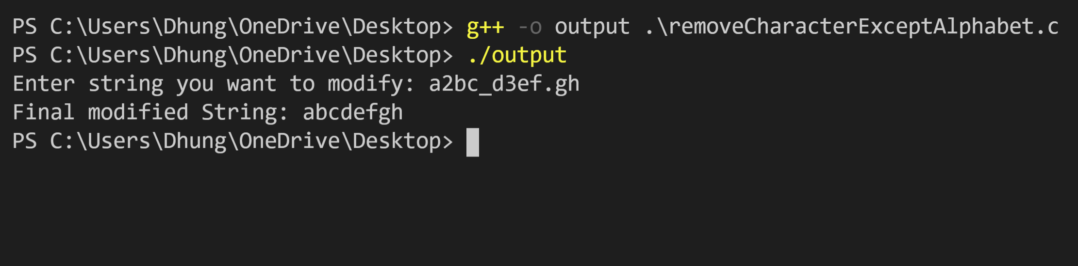

1. Write a program in C to replace the spaces of a string with an underscore(_).

Example:

Input: the quick brown fox jumps over the lazy dog

Output: the_quick_brown_fox_jumps_over_the_lazy_dog

**Program:**

//including the required libraries

#include<stdio.h>

#define SIZE 100

int main()

{

        //initialing the required variables

        int i;

        char oldChar;

        char newChar;

        char myString[100];

        //get the input from the user

        printf("Enter the string:");

        fgets(myString, SIZE, stdin);

        //character that need to be replaced

        oldChar = ' ';

        //character you want to replace with

        newChar = '_';

        //replacing oldChar with newChar

        for(i=0;myString[i]!='\0';i++)

        {

                if(myString[i]==oldChar)

                {

                        myString[i] = newChar;

                }

                else

                        continue;

        }

        //printing the modified string

        printf("The final string is:\n");

        puts(myString);

    return 0;

}

**OUTPUT**

